成绩
批阅
日期

台州学院
电子与信息工程学院实验报告
Experimental Report of the School of Electronic and Information Engineering

班级(class) 24计算机 学号(code) 2462710034L
姓名(full name) JENIRA SEKAR AZ ZAHRA 林樱

实验课程： web前端开发 (web front-end development)
实验名称:实验三 HTML编程实践 (lab3 HTML Programming Practice)

实验日期(Date)： 2025 年(year) 12 月(month) 2 日(day)

一、实验目的和任务（Experimental requirements & tasks）
1. 了解HTML 文档结构，学习如何编写HTML文档；
（understand the structure of HTML documents and learn how to write HTML documents）
- 学习基本的 HTML 标签，理解各种标签的使用场景;
( Learn basic HTML tags and understand the usage scenarios of various tags)
- 能够运用常用的编辑器建立简单的HTML文档。
(eable to create simple HTML documents using common editors.)
- 实验环境(Experimental environments)
r Windows+Hbuilderx
r Windows+VSCode
r Mac+Hbuilderx
r Max+VSCode
r Others
- 实验内容与步骤(Experimental procedure)
- Prepare the Environment:
Open VSCode editor on Mac and create a new file named album.html. Ensure a stable internet connection to load Bootstrap CDN resources.
- Write the Basic HTML Structure:
- Add the declaration and the <html lang="en"> root element.
- In the <head>, import Bootstrap CSS (<link> tag) and Bootstrap Icons.
- Add <title> as "Album Example" before <body>.

- Add the Navigation Bar (Navbar):
- Use <nav class="navbar navbar-expand-lg navbar-dark bg-dark"> to create a dark-themed navigation bar.
- Include a brand link (with camera icon), collapse button, and navigation menu (Home, Albums, More dropdown).
- Use data-bs-toggle attributes for responsive collapsing.

- Build the Album Header Section:
- Use <main class="container"> to create a container.
- Add the title 📷 Album and badge 3.
- Insert a description paragraph and action buttons (Primary and Secondary).
<div class="bg-body-white mx-auto my-4" style="max-width: 400px">
<div class="p-3 pb-0">
<h1 class="h1 mb-3 text-center">Album example</h1>
<p class="mb-3 text-center">
Something short and leading about the collection below—its contents, the creator, etc. Make it short, but
not too short so entirely. Simply skip over it.
</p>
<div class="d-flex gap-2 justify-content-center mb-4">
<button class="btn btn-primary">Main call to action</button>
<button class="btn btn-outline-secondary">Secondary action</button>
</div>
</div>
</div>

- Create the Card Grid:
- Use <div class="row g-4 py-5 row-cols-1 row-cols-lg-3"> for a 3-column responsive grid.
- Add
<div class="col">

</div>
for each card (total of 9).
Each card uses <div class="card shadow-sm">
<div class="card mb-0">
, containing:
  - Image.
<div class="bg-secondary text-white d-flex align-items-center justify-content-center">
<img src="img/me.jpg" alt="" class="img-fluid" />
</div>
  - Card body: supporting text, button group (View/Edit), and duration 9 mins.
<div class="card-body">
<p class="card-text">
This is a wider card with supporting text below as a natural lead-in to additional content. This content
is a little bit longer.
</p>
<div class="d-flex justify-content-between align-items-center">
<div class="btn-group">
<button class="btn btn-sm btn-primary">View</button>
<button class="btn btn-sm btn-outline-secondary">Edit</button>
</div>
<small class="text-body-secondary">9 mins</small>
</div>
</div>
</div>

  - Duplicate the card structure to fill 9 positions.

- Add the Footer:
- Use
<footer class="text-center text-body-secondary py-5 bg-light">
<div class="container">
<p class="mb-3">Album example is &copy; Bootstrap, please download and customize it for your use.</p>
<p class="mb-0">
<a href="#" class="text-body-secondary me-2">New to Bootstrap?</a>
<span class="mx-1">&middot;</span>
<a href="#" class="text-body-secondary mx-2">Visit the homepage</a>
<span class="mx-1">&middot;</span>
<a href="#" class="text-body-secondary ms-2">Read our getting started guide</a>
</p>
</div>
</footer>
- Include copyright statement and links (New to Bootstrap? etc.).

- Import Bootstrap JS:
- Add <script src="...bootstrap.bundle.min.js"> before </body> to support interactive components like dropdowns.

- Test and Preview:
- Preview the page in VSCode using the Live Server extension (or open the file directly).
- Check responsiveness: Resize the browser window to ensure cards stack into a single column on small screens.
- Verify all links and buttons (e.g., search form submission, Navbar collapse).
- Save and Screenshot:
- Save the HTML file.
- Use browser DevTools (Chrome/Safari) to capture a full-page screenshot as proof of the experimental results.
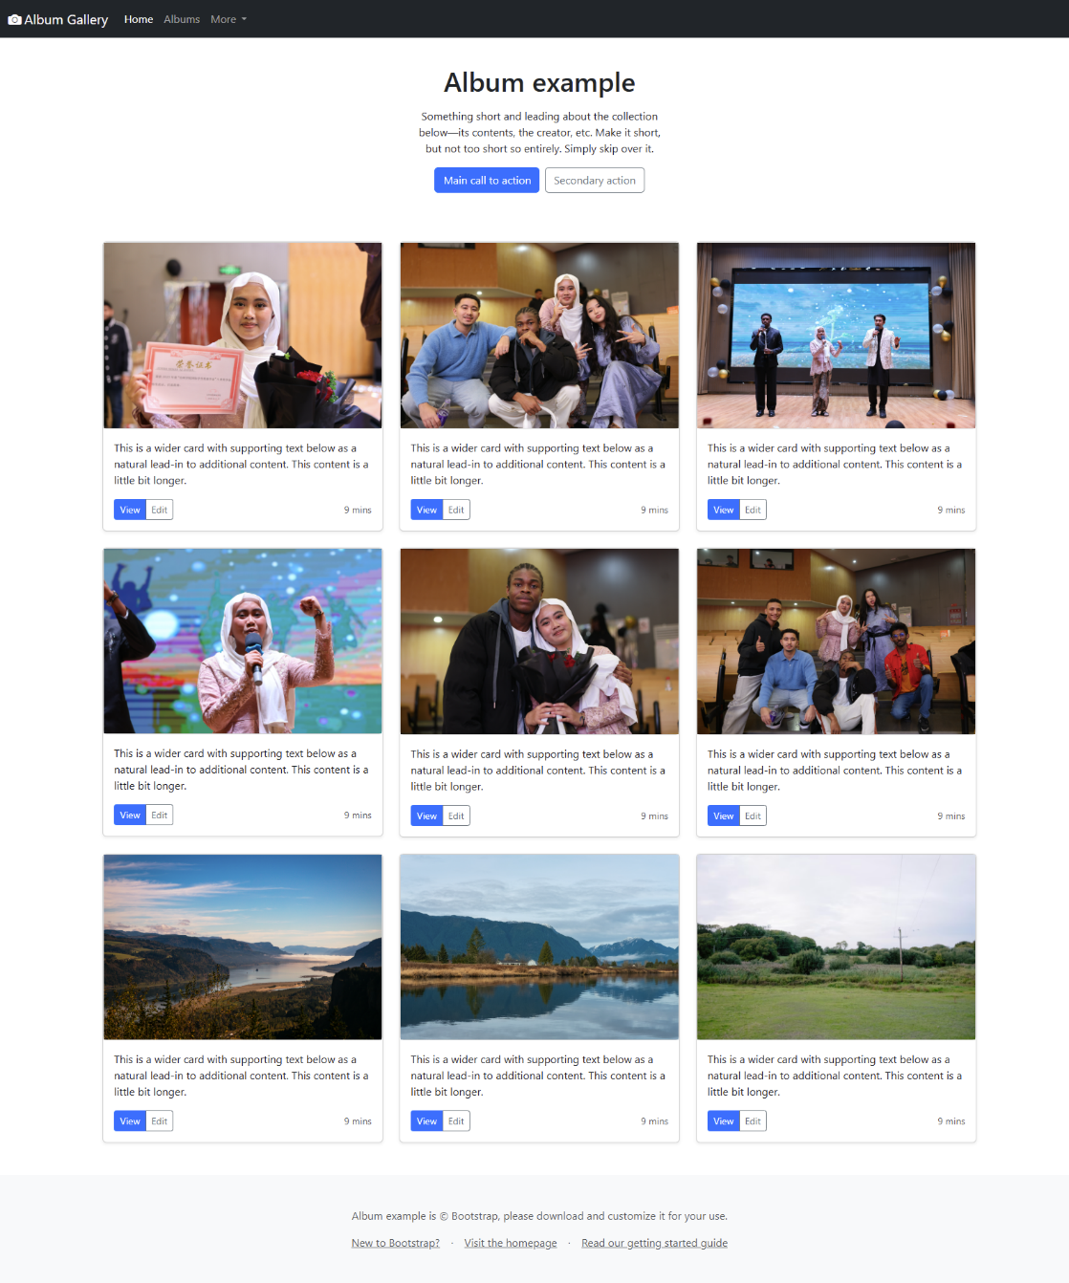

- 实验结果分析、思考、心得（Result reflection）
Through this experiment, I deepened my understanding of HTML document structure: from root elements to the use of semantic tags, which better organizes content and improves accessibility. Learning Bootstrap made me realize the framework's power in simplifying layouts, such as the Row/Col system avoiding manual float or Flexbox complexity. In the experiment, understanding the role of class attributes (like row-cols-lg-3) was crucial, making the code more concise and maintainable.
Challenges: Initially, I forgot to import the Bootstrap Icons font link, causing icons not to display; I quickly resolved it by checking the official documentation. This emphasized the importance of reading docs. Additionally, responsive testing requires multi-device simulation, and VSCode's extensions (like Live Server) greatly improved efficiency.

